Name: Vinayak P Bhupal
USN: 1NT19IS187
SEC: C
Batch: C2

MONGO DB

DATE:31/3/2022

SWITCHING TO MONGO
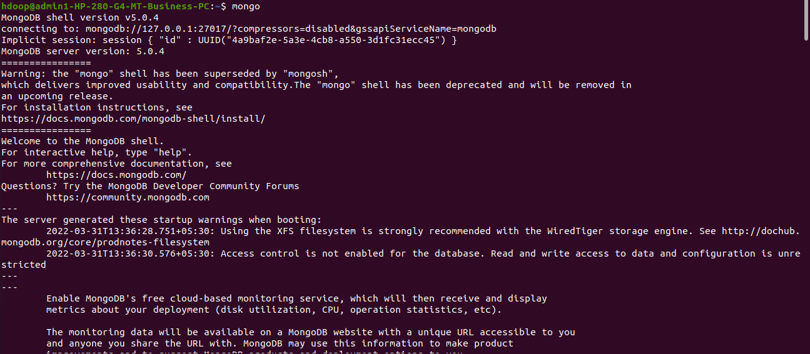
Command FOR SWITCHING TO DB HAVING NAME VINAYAK

use vinayak
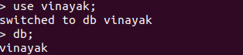

COMMAND FOR INSERTING THE DETAILS IN DOCUMNET

> db.vinayak.insertOne(
... name:"vinayak",
... age:22,
... branch:"ISE"
... )

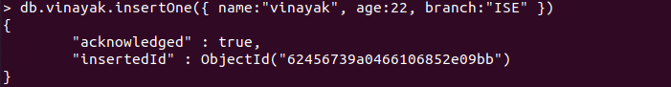

INSERTING MANY

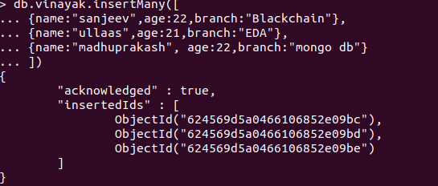

COMMAND FOR READING THE DETAILS

> db.vinayak.find()

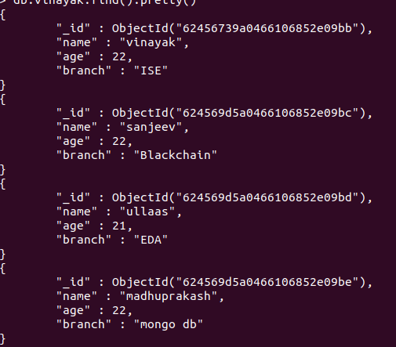

COMMAND TO FIND PARTICUL DETAIL

> db.vinayak.find( {name:"ullaas"})

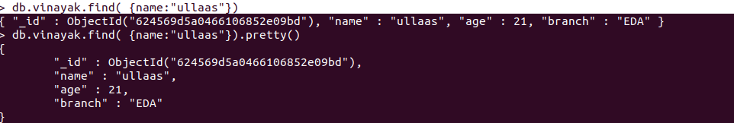

UPDATING COMMANDS

> db.vinayak.updateOne(
... {
... "name":"sanjeev"},
... {
... $set: { "branch":"ISE"}
... }
... )

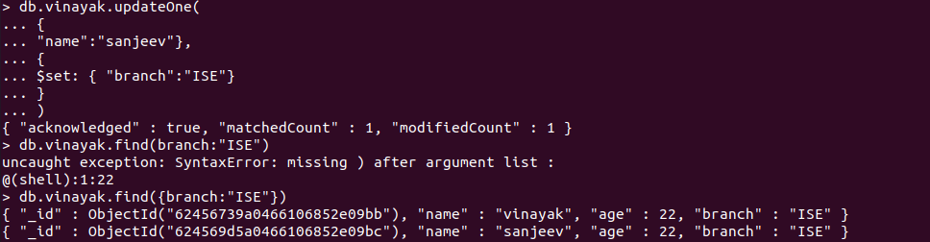

UDATE MANY

> db.vinayak.updateMany(
... {},
... {
... $set:{branch:"ISE"}
... }
... )

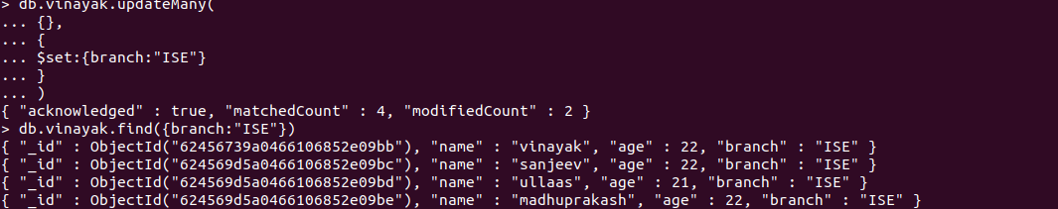

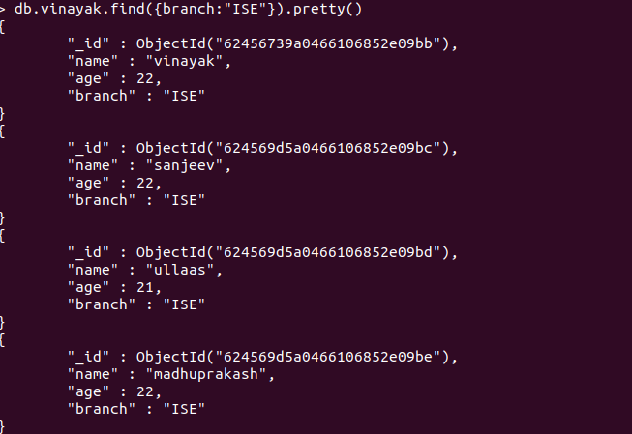

DELETE

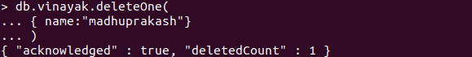

REPLACE

db.vinayak.replaceOne({ name:"ullaas"}, { name: "ullaas.M", age:"44", branch:"CSE"})

